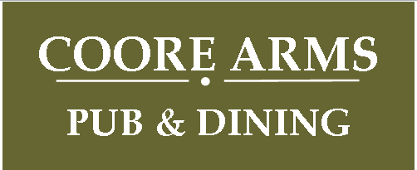

***APRIL***

***SPECIAL OFFER***

***WE’D LOVE TO SEE YOU SOON***

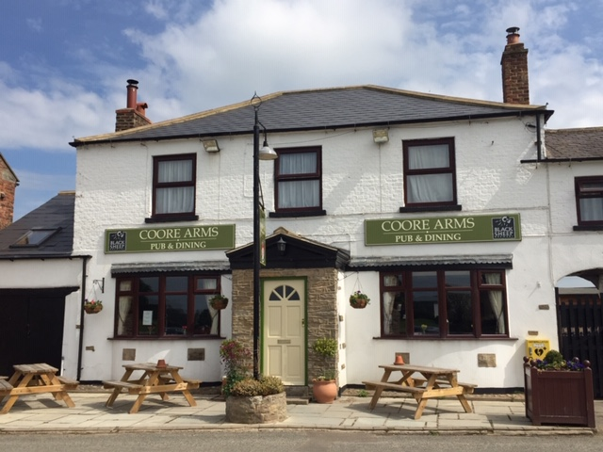

***THIS VOUCHER ENTITLES YOU TO A FREE PINT OF***

***BEER / LAGER OR A 175ml GLASS OF HOUSE WINE***

***AND***

***10% OF YOUR TOTAL BILL***

***VALID LUNCH OR EVENING***

***WEDNESDAY TO SATURDAY DURING APRIL***

***DON’T MISS OUT, CALL ON 01609 748215***

***TO RESERVE YOUR TABLE***